XX. Provide three bird adaptations that increase flight efficiency (6 pts). In general, how does each increase flight efficiency (6 pts)?

XX. Here is a close-up image of a feather vane. Note that I have labeled the rachis already. Please provide labels for barbs, proximal barbules, distal barbules, and hooklets (8 pts).
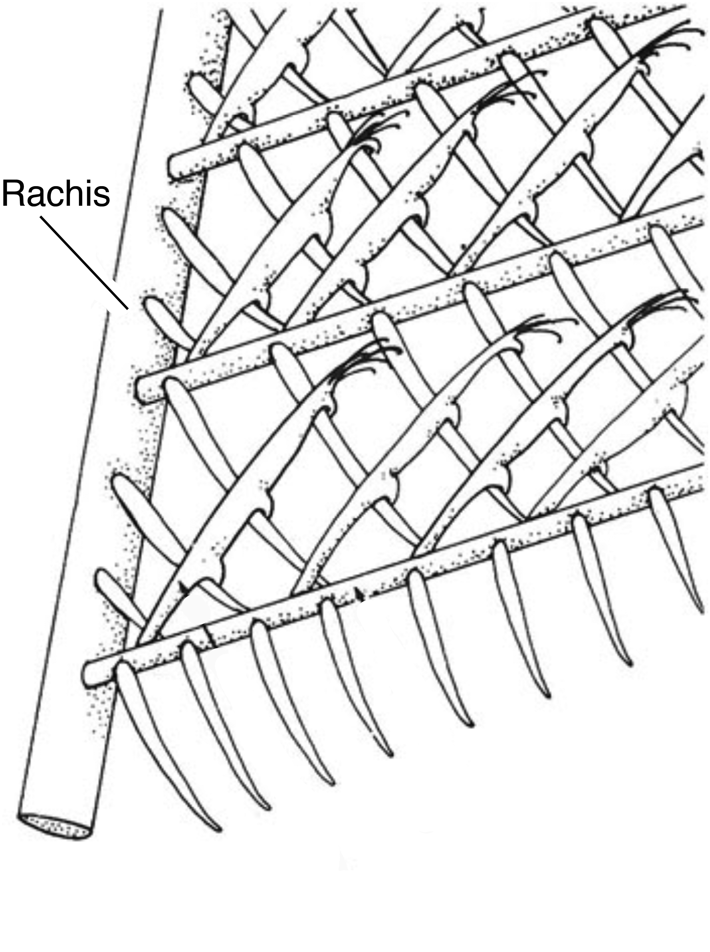

XX. Match the feather type with its diagrammatic depiction (4 pts).
_____. Semiplume a. 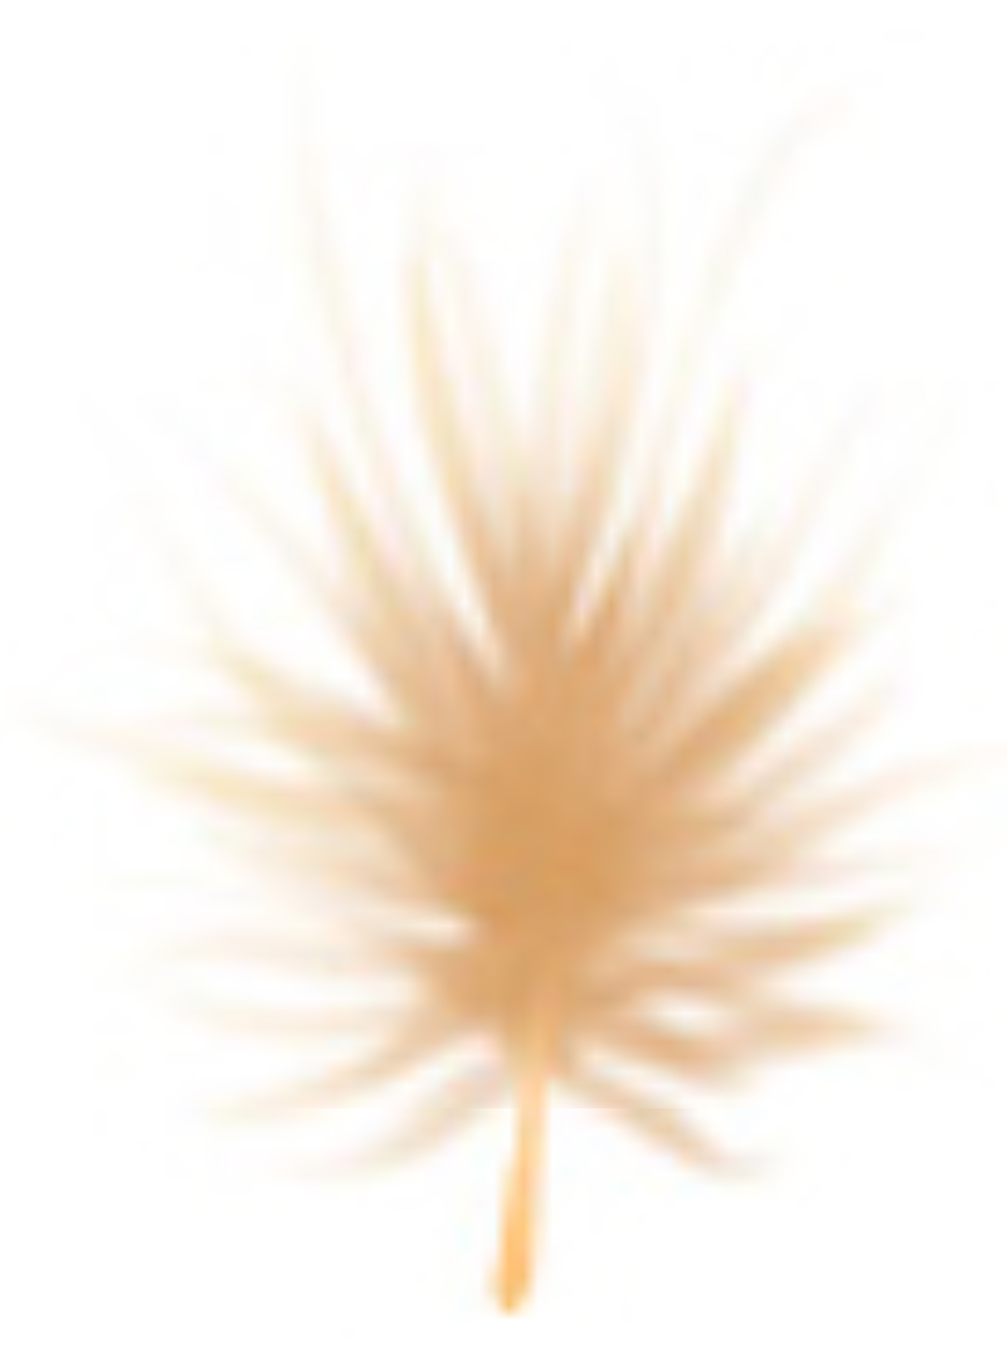
_____. Downy b. 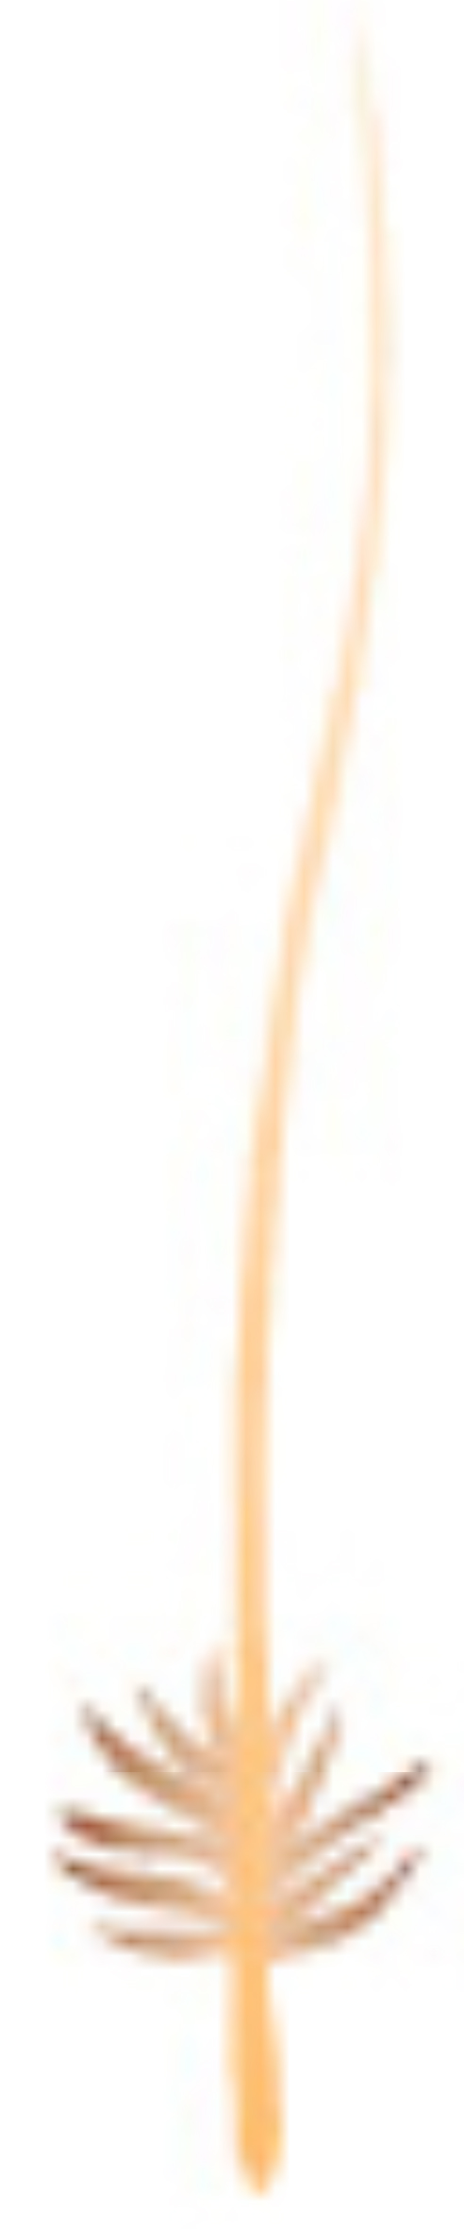
_____. Filoplume c. 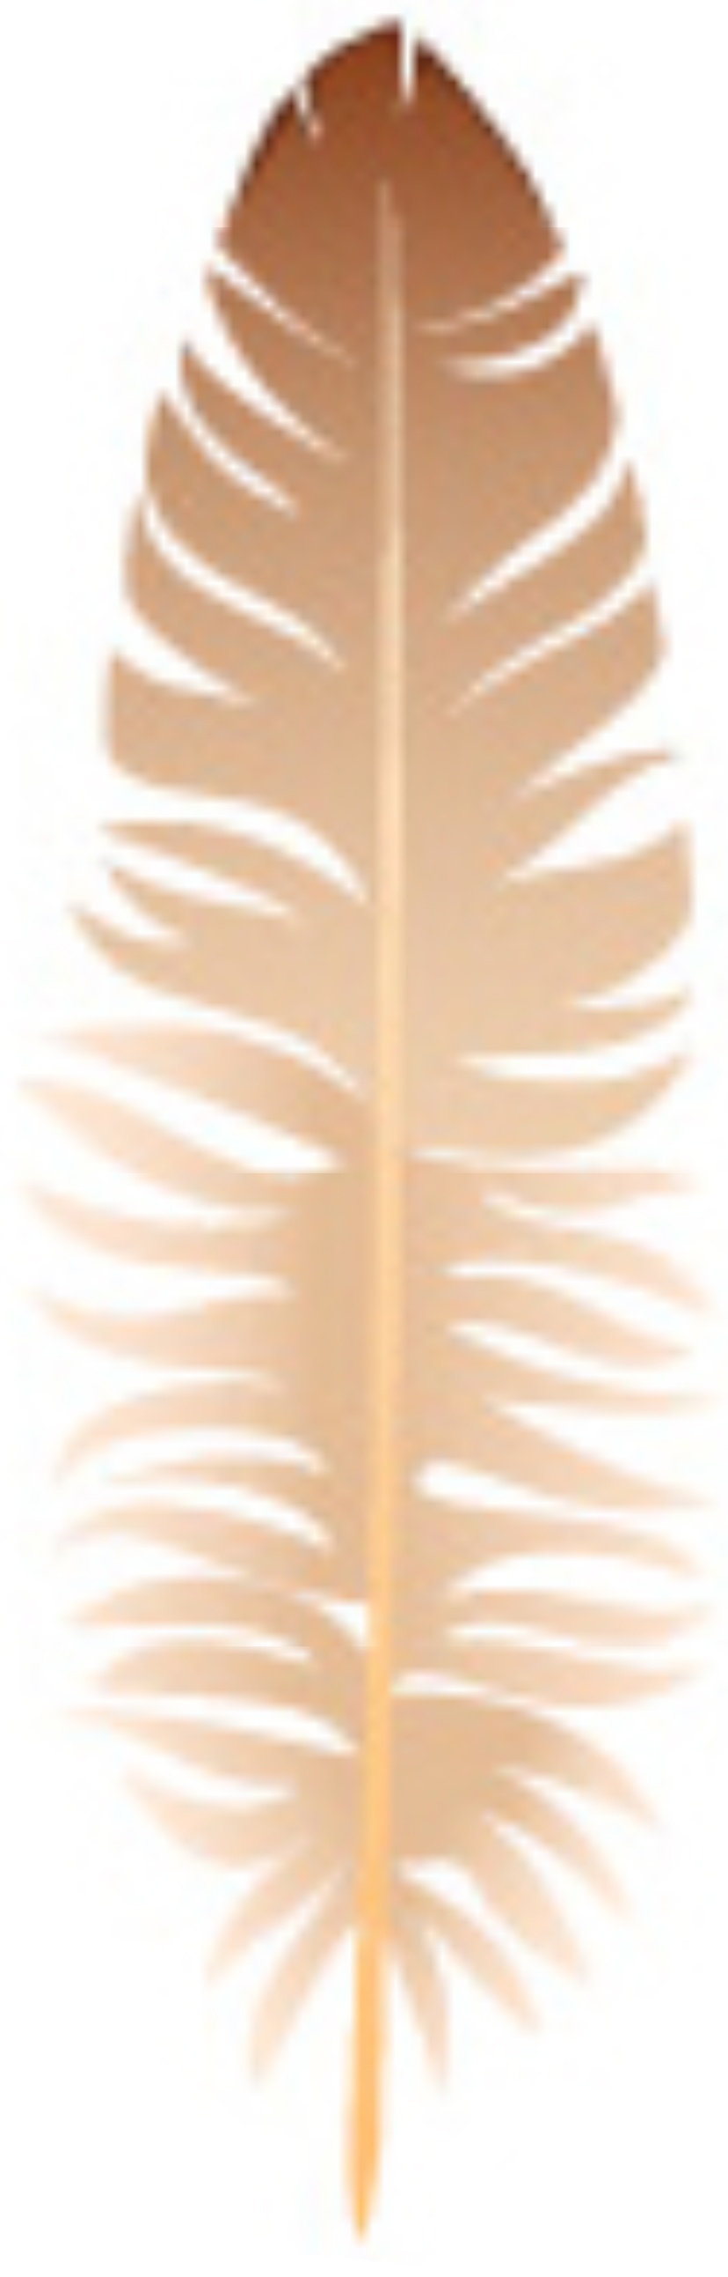
_____. Bristle d. 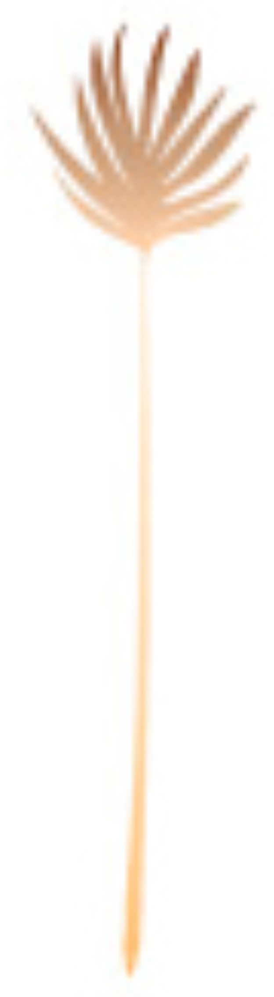

XX. Provide one function from each of the feather types in the question above (8 pts).

XX. The flight feather is one of the most complex feather types. Flight feathers possess a rachis with either symmetrical or asymmetrical vanes. They also possess barbules with hooklets, which results in the mass majority of the flight feather vane being pennaceous. Flight feathers are often referred to as feather types IV and V when describing the evolutionary trajectory of feathers. Below, please provide similar details for feather types I, II, and IIIa (6 pts) in comparison to what I provided for flight feathers above.

XX. If I was a bird getting ready to find a mate, what molting stage would I go through to reach my breeding plumage (2 pts)?

XX. Bird wings are specialized to provide both lift and thrust. Explain why thrust is important to lift (4 pts)?

XX. How do airfoils work? Basically, describe the speed of air moving over and under an airfoil (4 pts) and the resultant pressures on each side of an airfoil (4 pts).

XX. What are the two types of drag that can reduce lift (4 pts)? How are these types of drags related to the speed of air moving over an airfoil (4 pts)?

XX. Describe the angle of attack of the inner and outer portions of a bird wing during the upstroke and down stroke of flapping in a “typical bird” (not a humming bird). At what part of the flapping stroke is lift maximized and at what part is thrust maximized (4 pts)?

XX. If I was a bird that enjoyed slowly gliding over open spaces to find prey (like a hawk), describe what my wings might look like. Why? You may draw a representative wing but be certain your proportions are reasonably accurate. (6 pts)

